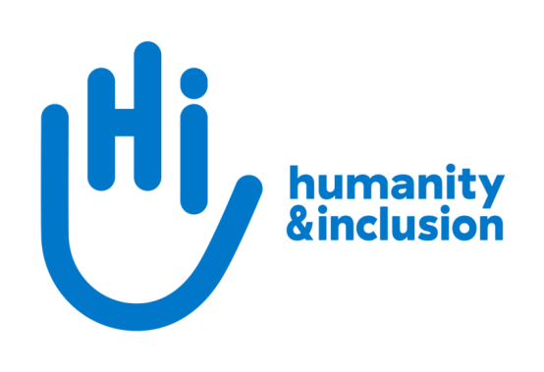

**Inclusive Governance Specialist**

**Application pack**

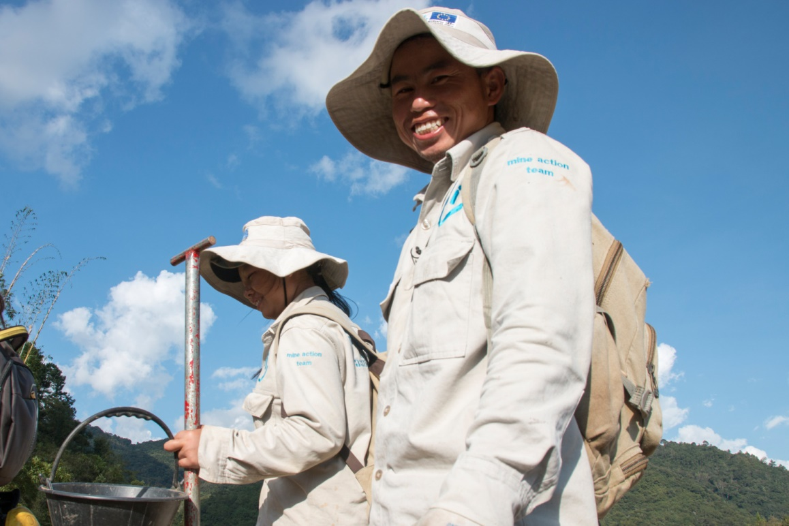

*HI de-miners in Houaphan Province, Laos*  ©N.Lozano Juez/HI

**Do you want to improve the lives of people with disabilities and vulnerable people?**

Humanity & Inclusion (HI) is an award-winning international development organisation working in situations of poverty and exclusion, conflict and disaster.

HI UK is looking for a dynamic, dedicated and organised Inclusive Governance Specialist to provide global expertise on inclusion in development and humanitarian contexts, with a particular focus on disability inclusion.

This is an exciting and varied role, where you will be part of an established multicultural team providing expertise and technical support for programmes around the world. You will contribute to the development of tools and international representation, while also providing support in developing major project opportunities.

**About Humanity & Inclusion (HI)**

Working alongside people with disabilities and vulnerable populations, we take action and raise awareness in order to respond to their essential needs, improve their living conditions and promote respects for their dignity and fundamental rights.

HI was co-winner of the 1997 Nobel Peace Prize for our campaign for the Mine Ban Treaty. We were also awarded the 2011 Hilton Humanitarian prize in recognition of our contribution to alleviating human suffering and supporting the most vulnerable people.



*Grace, 5, was born with a congenital disability. She lives in Kakuma refugee camp. Having received a prosthesis from HI, she goes to school and can play like any other child. She wants to be a teacher when she grows up. Here she is with Stella, her HI physiotherapist.*

©Patrick Meindhardt/HI

**Outraged by the injustice faced by people with disabilities and vulnerable populations, we aspire to a world of solidarity and inclusion, enriched by our differences, and where everyone can live in dignity.**

Respect for the rights of people with disabilities has been at the heart of HI’s approach sinceit was founded in 1982. Over forty years on, our organisation is still working and fighting around the world to improve the living conditions of people with disabilities and other vulnerable people and to ensure that their fundamental rights are respected.

**About Humanity & Inclusion UK (HI UK)**

HI UK is a member of the Humanity & Inclusion Network, which is comprised of a Federation and eight national associations. As part of the Network, HI UK works towards a common strategy while maintaining a distinct identity as a British organisation. The Federation is responsible for implementing the Network’s social missions in around fifty countries. It operates under the names “Humanity & Inclusion” or “Handicap International”, depending on the country.

HI has an ambitious delivery plan in the UK, as part of our 2016-25 strategy, [*For More Solidarity and Inclusion in the World*](https://hi.org/en/our-strategy).

# Equal opportunities policy

HI UK is committed to diversity and inclusion. We recognise that discrimination shapes the opportunities that many people have in society and that people have different needs in order to realise their full potential. Addressing this requires organisations to be proactive in creating environments that encourage the inclusion and development of all. Though we still have a long way to go, inclusion is central to our identity at HI UK and we are strongly committed to the continuous work that it requires.

We are particularly interested in hearing from candidates with disabilities and/or from minority ethnic backgrounds to help make us more representative. If you have a disability and meet the minimum requirements for the role, we will guarantee you an interview.

# Employee benefits

* All full-time employees are entitled to 28 days’ holiday per year in addition to UK public holidays.

* Training and development opportunities are open to all staff and will be provided in order to support them to fulfil their roles.
* We value all our employees and strive to support them in their professional lives. This includes offering flexible-working opportunities, including home-working and flexible hours.

* We offer a competitive workplace pension scheme, matching contributions up to 6% of gross salary.
* We are positive about employing persons with disabilities and are proud to be accredited as a Disability Confident Employer.
* We offer a Worklife Support Employee Assistance Programme, which provides confidential information, support and counselling.
* We strive to create a diverse and inclusive working environment and we are constantly looking at ways to improve our policies, processes and culture.
* Our office is conveniently located in SE1 with great transport links to Waterloo, Blackfriars, London Bridge and the London Underground. We run a hybrid-working approach, with colleagues expected to work from the office at least six days a month.

**JOB DESCRIPTION**

**1. JOB TITLE** Inclusive Governance Specialist

**2.** **ORGANISATION** Humanity & Inclusion UK (HI UK)

**3. SALARY & HOURS** £42,366, 37.5 hours a week

**4.** **REPORTING TO** Inclusive Governance & Humanitarian Action Unit Manager

(in Lyon) and HI UK Chief Executive (in London)

**5.** **DURATION** Permanent

**6.** **LOCATION** Based in London (SE1) with some remote working and

travel worldwide.

The applicant must have the right to work in the UK.

Note: this post is also being advertised in other locations (France, Belgium, US and Canada)

**7. BACKGROUND INFORMATION AND PURPOSE OF THE POST**

The role sits in the Protection & Risk Reduction Division, whose role is to support the implementation of HI’s institutional "Disability Age Gender" policy in our country programmes. As Inclusive Governance Specialist, you will provide global expertise on inclusion in development and humanitarian contexts, with a particular focus on disability inclusion. You will work in close collaboration with another Inclusive Governance specialist and with all other technical specialists.

**8. MAIN DUTIES AND RESPONSIBILITIES**

**Technical support**

Support the design and effective implementation of HI’s inclusive governance technical frameworks, standards and approaches (50%).

* Contribute to the development and deployment of frameworks and tools for the four pillars of inclusive governance: a) citizenship, legal empowerment and political participation; b) inclusive policies; c) inclusive local development; and d) support to civil society and advocacy
* Provide guidance on meaningful participation of persons with disabilities and their representative organisations in all HI interventions
* Bring inclusive-development expertise to advise the work of colleagues in other sectors – both at the country level and in our international advocacy
* Help develop multidisciplinary approaches to the development-humanitarian nexus
* Support country teams in the identification, development and implementation of major projects
* Inspire and steer the development of innovative projects, studies and research, as well as the collection of best practices and lessons learned in the sector
* Co-lead a network of professionals in the sector
* Contribute to the implementation and monitoring of technical strategies

**Project support**

Provide technical support to partners and country teams by developing their capacity and strengthening the quality and impact of HI’s projects linked to inclusive governance (25%).

* Provide regular technical support for the design, implementation and evaluation of projects related to the inclusion of persons with disabilities and/or excluded groups.
* Provide technical support to HI staff and partners in the various areas covered by the sector, with a focus on capacity building and empowerment of civil-society organisations, persons with disabilities and their representative organisations.
* Support the technical quality of HI projects in terms of inclusive governance
* Provide technical advice during the development of operational strategies and programmes
* Participate in the identification, recruitment and third-party assessment of technical personnel in the sector
* Promote the development of technical assistance projects to external actors

**External influence**

Monitor innovations and developments in the sector, engage in professional networks and contribute to HI's external outreach (25%).

* Analyse and influence existing and new professional networks
* Encourage and support HI programmes in meaningful participation of networks of civil-society organisations and organisations of persons with disabilities (national, regional and international)
* Participate in major events in the sector, representing HI as required
* Contribute to HI’s international advocacy campaigns
* Support HI UK in promoting our mission in the UK through networking and external representation as required

**Other duties**

* Maintain a positive and collaborative working relationship with colleagues across HI UK and the global HI Network
* Actively contribute to the HI UK operational plan and internal staff meetings
* Any other activities commensurate with the level of the post, as may be required by the Chief Executive or Head of Team

**Conduct and safeguarding**

Respect and dignity of all the people we support and come into contact with are at the heart of HI’s approach. All employees, volunteers (including trustees), partners, suppliers and consultants working with HI UK are expected to adhere to our [Code of Conduct and related policies**.**](https://hi.org/sn_uploads/document/ID_CodeOfConduct.pdf)

Our commitment to safeguarding means we seek to ensure that no harm comes to people as a result of contact with the organisation’s programmes, operations or people. This means ensuring the safety and protection of groups, including children and vulnerable adults, with whom the organisation is in contact, establishing safe and respectful workplaces that are free from harassment, abuse and discrimination, and maintaining HI’s reputation and high standards by preventing, addressing and learning from instances of wrongdoing.

This post is Safeguarding Level 2, which means a Basic DBS check is required (unless the content of the post changes) as the postholder will be travelling to programmes and will be in contact with vulnerable people.

**9. PERSON SPECIFICATION**

|  |
| --- |
| **ESSENTIAL** |
| Postgraduate-level expertise or equivalent experience |
| Significant experience in at least two of the following areas: inclusion of marginalised groups, inclusive governance and policy development, promotion and monitoring of human rights, community mobilisation and local development, advocacy and support for civil society |
| Awareness and experience of working with international human rights treaties and frameworks |
| A good command of project management in international development contexts |
| A collaborative and team-oriented approach |
| Strong self-motivation |
| Ability to work effectively in an international and multicultural organisation |
| Willingness to travel and to work outside of office hours when necessary |
| Good IT skills (Word, Excel, PowerPoint, Outlook, Teams) |
| Fluent English |
| Passion for improving the lives of the world’s most vulnerable people |
| Commitment to creating and maintaining an inclusive and protective environment for everyone that comes in contact with the organisation |
|  |
|  |
| **DESIRABLE** |
| Lived experience of disability or from one of our countries of operation |
| French-language proficiency |

**APPLICATION PROCESS**

To apply, please submit your CV and a covering letter via the following link: <http://www.jobs.net/j/JzLbpFtl?idpartenaire=130&jobdetails=true>

If you disclose a disability during your application process and you meet the minimum criteria for the role, we will contact you to discuss any reasonable adjustment you might need at the interview. However, if you have not disclosed, please be aware that any candidate invited for interview will be asked if any reasonable adjustments are needed.

If you wish to disclose a disability please do so in your covering letter.

## Closing date: 3rd August

For further information, please contact Humanity & Inclusion UK on 0870 774 3737 or by email at [recruitment.uk@hi.org](mailto:recruitment.uk@hi.org).