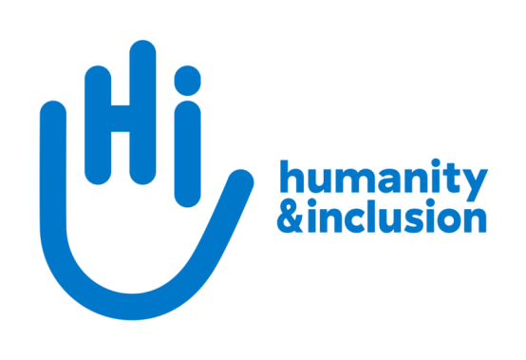

**International Legacies Officer**

**Application pack**

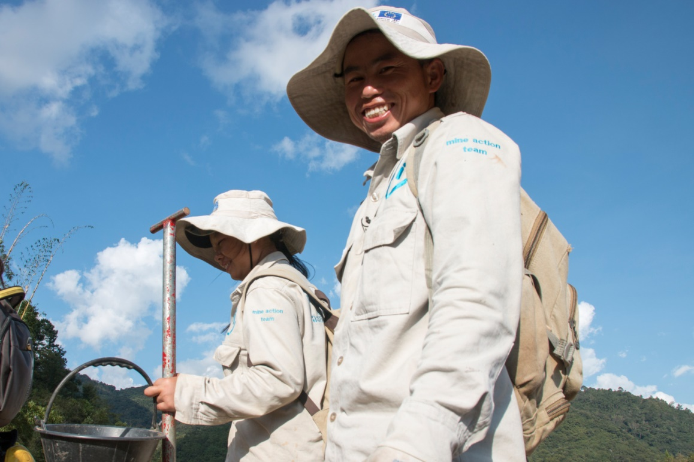

*HI de-miners in Houaphan Province, Laos*  ©N.Lozano Juez/HI

**Do you want to improve the lives of people with disabilities and vulnerable people?**

Humanity & Inclusion (HI) is an award-winning international development organisation working in situations of poverty and exclusion, conflict and disaster.

HI UK is looking to recruit an International Legacies Officer to join our small and dynamic team. The postholder will develop and process legacy gifts and bequests across some of our European associations, including the UK, France, Belgium and Luxembourg. If you are fluent in French and English, have a strong interest in comparative law, a great team spirit and an adaptable, responsive and can-do approach, we would love to hear from you.

**About Humanity & Inclusion (HI)**

Working alongside people with disabilities and vulnerable populations, we take action and raise awareness in order to respond to their essential needs, improve their living conditions and promote respects for their dignity and fundamental rights.

HI was co-winner of the 1997 Nobel Peace Prize for our campaign for the Mine Ban Treaty. We were also awarded the 2011 Hilton Humanitarian prize in recognition of our contribution to alleviating human suffering and supporting the most vulnerable people.

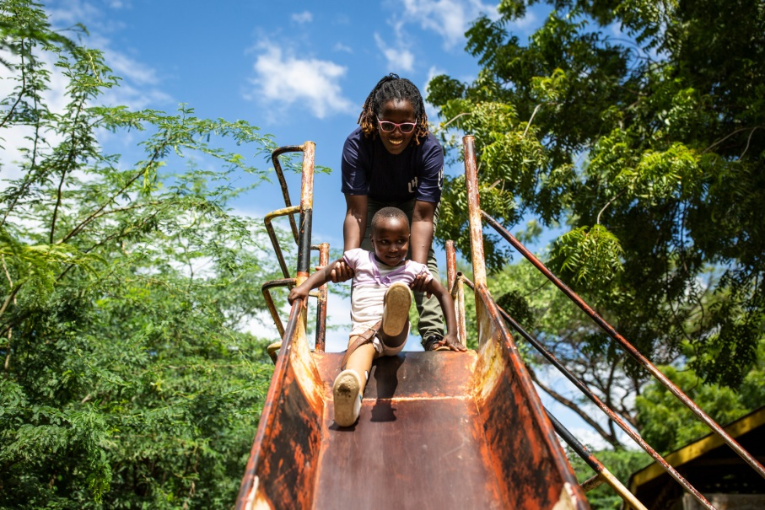

*Grace, 5, was born with a congenital disability. She lives in Kakuma refugee camp. Having received a prosthesis from HI, she goes to school and can play like any other child. She wants to be a teacher when she grows up. Here she is with Stella, her HI physiotherapist.*

©Patrick Meindhardt/HI

**Outraged by the injustice faced by people with disabilities and vulnerable populations, we aspire to a world of solidarity and inclusion, enriched by our differences, and where everyone can live in dignity.**

Respect for the rights of people with disabilities has been at the heart of HI’s approach sinceit was founded in 1982. Over forty years on, our organisation is still working and fighting around the world to improve the living conditions of people with disabilities and other vulnerable people and to ensure that their fundamental rights are respected.

**About Humanity & Inclusion UK (HI UK)**

HI UK is a member of the Humanity & Inclusion Network, which is comprised of a Federation and eight national associations. As part of the Network, HI UK works towards a common strategy while maintaining a distinct identity as a British organisation. The Federation is responsible for implementing the Network’s social missions in around fifty countries. It operates under the names “Humanity & Inclusion” or “Handicap International”, depending on the country.

HI has an ambitious delivery plan in the UK, as part of our 2016-25 strategy, [*For More Solidarity and Inclusion in the World*](https://hi.org/en/our-strategy).

# Equal opportunities policy

HI UK is committed to diversity and inclusion. We recognise that discrimination shapes the opportunities that many people have in society and that people have different needs in order to realise their full potential. Addressing this requires organisations to be proactive in creating environments that encourage the inclusion and development of all. Though we still have a long way to go, inclusion is central to our identity at HI UK and we are strongly committed to the continuous work that it requires.

We are particularly interested in hearing from candidates with disabilities and/or from minority ethnic backgrounds to help make us more representative. If you have a disability and meet the minimum requirements for the role, we will guarantee you an interview.

# Employee benefits

* All full-time employees are entitled to 28 days’ holiday per year in addition to UK public holidays.

* Training and development opportunities are open to all staff and will be provided in order to support them to fulfil their roles.
* We value all our employees and strive to support them in their professional lives. This includes offering flexible-working opportunities, including home-working and flexible hours.

* We offer a competitive workplace pension scheme, matching contributions up to 6% of gross salary.
* We are positive about employing persons with disabilities and are proud to be accredited as a Disability Confident Employer.
* We offer a Worklife Support Employee Assistance Programme, which provides confidential information, support and counselling.
* We strive to create a diverse and inclusive working environment and we are constantly looking at ways to improve our policies, processes and culture.
* Our office is conveniently located in SE1 with great transport links to Waterloo, Blackfriars, London Bridge and the London Underground. We run a hybrid-working approach, with colleagues currently expected to work from the office at least six days a month.

**JOB DESCRIPTION**

**1. JOB TITLE** International Legacies Officer

**2.** **ORGANISATION** Humanity & Inclusion UK (HI UK)

**3. SALARY & HOURS** £36,400 per annum / 37.5 hours a week

**4.** **REPORTING TO** Global Specialist in Planned Giving (Based in Lyon)

**5.** **DURATION** Permanent

**6.** **LOCATION** Based in London (SE1) with some remote working

Regular travel to Europe required

The applicant must have the right to work in the UK*

* Note: the same role is being advertised simultaneously in Lyon, Paris, Brussels and Luxembourg

**7. BACKGROUND INFORMATION AND PURPOSE OF THE POST**

HI has an ambitious strategy to grow its fundraising from legacies income. This position will help turn that ambition into reality. Reporting to the Global Specialist in Planned Giving, the International Legacies Officer will participate in the development and processing of legacies, bequests and other planned-giving portfolios for our network of National Associations, with a particular focus on France, Belgium, Luxembourg and the UK.

**8. MAIN DUTIES AND RESPONSIBILITIES**

1. **Contribute to the effective management of inheritance files managed by our French, Belgian, Luxembourg and UK associations,** and, if requested, our other national associations (Switzerland, Germany, Canada, US), in accordance with local rules of law:

* Support administrative, legal and accounting management of legacies, bequests, donations and life insurance policies benefiting Humanity and Inclusion / Handicap International. This will include:
  + legal and asset analysis of legacy and bequest files
  + preparation of files for submission to the relevant board
  + implementation of estate settlements and the liquidation process, including analysing notarial deeds, updating the database, and monitoring receipts and disbursements
  + accounting follow-up of all planned-giving files
* Assist in liquidating and optimising property assets, including:
  + taking part in and monitoring property inventories
  + organising and monitoring the clearing out, maintenance, securing of lots, payment of service charges, etc
  + participating in the listing decision process and the analysis of bids
  + processing and monitoring property sales transactions
  + analysis of draft notarial deeds
* Provide overall support for the division’s administrative activities.

1. **Contribute to the development of legacies management in HI**

* Provide legal support to the relationship marketing teams of each national association to enable them to answer questions from legacy prospects and pledgers and to assist them with their programme.
* Provide legal support to the marketing teams of each national association in their work to promote legacies (creation of communication tools, etc);
* Take part in meetings/appointments with external contacts (notaries, co-legislative associations etc.) in order to build up a network that will contribute to develop HI's reputation in the legacy sector and to facilitate the management of files.
* Help promote legacies giving in our national associations, both internally (through training courses) and externally (through testator events, Congress of Notaries, exhibitions, etc.).

**Conduct and safeguarding**

Respect and dignity of all the people we support and come into contact with are at the heart of HI’s approach. All employees, volunteers (including trustees), partners, suppliers and consultants working with HI UK are expected to adhere to our [Code of Conduct and related policies**.**](https://hi.org/sn_uploads/document/ID_CodeOfConduct.pdf)

Our commitment to safeguarding means we seek to ensure that no harm comes to people as a result of contact with the organisation’s programmes, operations or people. This means ensuring the safety and protection of groups, including children and vulnerable adults, with whom the organisation is in contact, establishing safe and respectful workplaces that are free from harassment, abuse and discrimination, and maintaining HI’s reputation and high standards by preventing, addressing and learning from instances of wrongdoing.

This post is Safeguarding Level 1, which means no DBS check is required (unless the content of the post changes*)*.

**10. PERSON SPECIFICATION**

|  |
| --- |
| **ESSENTIAL** |
| Qualifications in probate and trust law or equivalent professional experience |
| Experience in legacies and estate management |
| Strong interest in comparative law |
| Rigour, adaptability, responsiveness, discretion, and a high degree of diplomacy |
| Fluency in French and English |
| Enjoy working in a multicultural environment |
| Comfortable using IT tools |
| Collaborative team player |
| Commitment to creating and maintaining an inclusive and protective environment for everyone that comes in contact with the organisation |
|  |
| **DESIRABLE** |
| Experience of working in an international multi-cultural charity/organisation |
| Lived experience of disability or from one of our countries of operation |
| Knowledge of legacy accounting |

**APPLICATION PROCESS**

To apply, please send your CV and a covering letter via the following link:

<http://www.jobs.net/j/JeRQNVGi?jobdetails=true>

If you disclose a disability during your application process and you meet the minimum criteria for the role, we will contact you to discuss any reasonable adjustment you might need at the interview. However, if you have not disclosed, please be aware that any candidate invited for interview will be asked if any reasonable adjustments are needed. If you wish to disclose a disability please do so in your covering letter.

Closing date: 20th July 2023. Applications will be considered on a rolling basis. We encourage you to apply as soon as possible.

For further information, please contact Humanity & Inclusion UK on 0870 774 3737 or by email at [recruitment.uk@hi.org](mailto:recruitment.uk@hi.org).