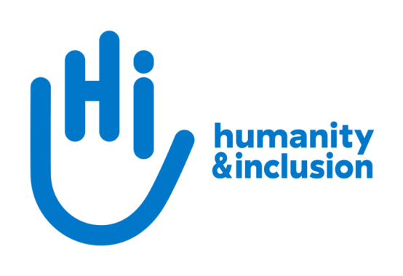

**Head of Institutional Relations (maternity cover)**

**Application pack**

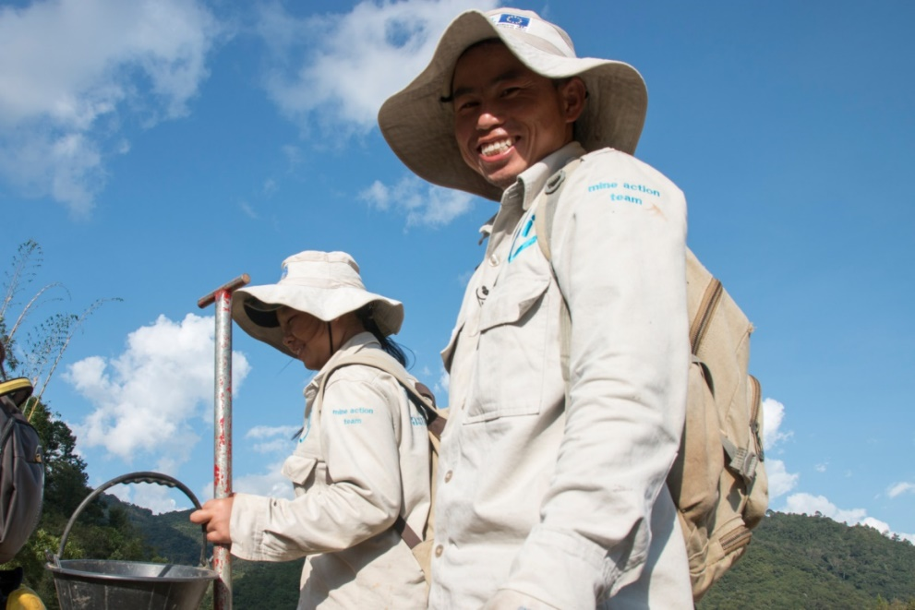

*HI de-miners in Houaphan Province, Laos*  ©N.Lozano Juez/HI

**Do you want to improve the lives of people with disabilities and vulnerable people?**

Humanity & Inclusion (HI) is an award-winning international development organisation working in situations of poverty and exclusion, conflict and disaster.

HI UK is looking for a Head of Institutional Relations (maternity cover) to lead our engagement with institutional donors, programme partners and allies in the UK. This is a fantastic opportunity to lead a dynamic team in the delivery and implementation of an ambitious institutional-relations strategy. With a particular focus on the FCDO, you will build partnerships and maximise income and influence to achieve our strategic aims. As a member of the HI UK Leadership Team, you will also play an important role in shaping the culture and direction of the organisation as a whole.

**About Humanity & Inclusion (HI)**

Working alongside people with disabilities and vulnerable populations, we take action and raise awareness in order to respond to their essential needs, improve their living conditions and promote respects for their dignity and fundamental rights.

HI was co-winner of the 1997 Nobel Peace Prize for our campaign for the Mine Ban Treaty. We were also awarded the 2011 Hilton Humanitarian prize in recognition of our contribution to alleviating human suffering and supporting the most vulnerable people.



*Grace, 5, was born with a congenital disability. She lives in Kakuma refugee camp. Having received a prosthesis from HI, she goes to school and can play like any other child. She wants to be a teacher when she grows up. Here she is with Stella, her HI physiotherapist.*

©Patrick Meindhardt/HI

**Outraged by the injustice faced by people with disabilities and vulnerable populations, we aspire to a world of solidarity and inclusion, enriched by our differences, and where everyone can live in dignity.**

Respect for the rights of people with disabilities has been at the heart of HI’s approach sinceit was founded in 1982. Over forty years on, our organisation is still working and fighting around the world to improve the living conditions of people with disabilities and other vulnerable people and to ensure that their fundamental rights are respected.

**About Humanity & Inclusion UK (HI UK)**

HI UK is a member of the Humanity & Inclusion Network, which is comprised of a Federation and eight national associations. As part of the Network, HI UK works towards a common strategy while maintaining a distinct identity as a British organisation. The Federation is responsible for implementing the Network’s social missions in around fifty countries. It operates under the names “Humanity & Inclusion” or “Handicap International”, depending on the country.

HI has an ambitious delivery plan in the UK, as part of our 2016-25 strategy, [*For More Solidarity and Inclusion in the World*](https://hi.org/en/our-strategy).

# Equal opportunities policy

HI UK is committed to diversity and inclusion. We recognise that discrimination shapes the opportunities that many people have in society and that people have different needs in order to realise their full potential. Addressing this requires organisations to be proactive in creating environments that encourage the inclusion and development of all. Though we still have a long way to go, inclusion is central to our identity at HI UK and we are strongly committed to the continuous work that it requires.

We are particularly interested in hearing from candidates with disabilities and/or from minority ethnic backgrounds to help make us more representative. If you have a disability and meet the minimum requirements for the role, we will guarantee you an interview.

# Employee benefits

* All full-time employees are entitled to 28 days’ holiday per year in addition to UK public holidays.

* Training and development opportunities are open to all staff and will be provided in order to support them to fulfil their roles.
* We value all our employees and strive to support them in their professional lives. This includes offering flexible-working opportunities, including home-working and flexible hours.

* We offer a competitive workplace pension scheme, matching contributions up to 6% of gross salary.
* We are positive about employing persons with disabilities and are proud to be accredited as a Disability Confident Employer.
* We offer a Worklife Support Employee Assistance Programme, which provides confidential information, support and counselling.
* We strive to create a diverse and inclusive working environment and we are constantly looking at ways to improve our policies, processes and culture.
* Our office is conveniently located in SE1 with great transport links to Waterloo, Blackfriars, London Bridge and the London Underground. We run a hybrid-working approach, with colleagues expected to work from the office at least six days a month.

**JOB DESCRIPTION**

**1. JOB TITLE** Head of Institutional Relations (maternity cover)

**2.** **ORGANISATION** Humanity & Inclusion UK (HI UK)

**3. SALARY & HOURS** £51,420 - 37.5 hours per week

**4.** **REPORTING TO** Chief Executive

**5.** **RESPONSIBLE FOR** 3 Programme Funding Officers

**6.** **DURATION** 12 months (maternity cover, subject to possible

extension); ideally starting in early November

**7.** **LOCATION** Based in London (SE1) with some remote working

The applicant must have the right to work in the UK

**8. BACKGROUND INFORMATION AND PURPOSE OF THE POST**

The Head of Institutional Relations leads HI’s engagement with institutional donors, programme partners and allies in the UK, working closely with colleagues from across the global HI Federation, including our country programmes and our technical departments.

You will lead a dynamic team in the delivery and implementation of an ambitious institutional-relations strategy. With a particular focus on the FCDO, you will build partnerships and maximise income and influence to achieve our strategic aims. This will involve managing relations with a wide range of actors, building our profile and responding quickly and effectively to opportunities. You will oversee and strengthen our compliance with UK donor requirements, ensure our programmes are effectively supported to implement grants and consolidate our capacity to bid for and manage commercial contracts.

As a member of the HI UK Leadership Team, you will also play an important role in shaping the culture and direction of the organisation as a whole.

**9. MAIN DUTIES AND RESPONSIBILITIES**

**Leadership and management**

* Implement our ambitious plan for institutional relations, staying aligned with the organisation’s objectives and responding appropriately to the external environment
* Contribute to the implementation of the Network-wide institutional-funding strategy
* Lead, empower and motivate your team to achieve their goals, providing support as needed
* Manage the team budget, including planning, phasing and forecasting in line with the organisation’s financial procedures
* Participate as an active and constructive member of the Leadership Team, promoting a positive culture, modelling excellent behaviour and supporting cross-organisational initiatives
* Provide timely and accurate reporting to the Chief Executive, trustees and Federation as required

**Institutional relations**

* Lead the team in ambitious engagement strategies for all donors in the portfolio, particularly the FCDO, strengthening existing relationships and, where appropriate, developing new ones
* Ensure the team develops and maintains expertise on UK donor priorities, expectations and compliance requirements and is proactively analysing, interpreting and sharing this knowledge internally with relevant colleagues across the Federation
* With your team, build the ability of our country programmes to engage with the FCDO locally and to comply with UK donor requirements, including through training
* Oversee the process of identifying, analysing and sharing new UK funding opportunities with relevant colleagues, taking a lead when needed on coordinating large multi-country/framework bids to UK donors
* Maintain a network of contacts at other organisations and, working closely with operational colleagues, build relationships with potential partners, including supporting the development of consortia for new bids when required
* Contribute to building HI’s capacity to bid for and manage commercial contracts, including frameworks
* Support the team with risk-based contract analysis and negotiation, due diligence and donor compliance
* Ensure your team is delivering timely and high-quality reporting and grant/contract management, including follow-up of payment requests and tracking
* Oversee the team’s information management tools and champion HI-wide internal processes and tools
* Participate in the Bond Disability and Development Group, including supporting its influencing to promote greater emphasis on disability inclusion by the UK Government
* Monitor and respond to threats and opportunities relating to the UK aid budget and aid policy
* Support your team, the Chief Executive and technical colleagues to engage appropriately with other relevant networks in the UK to influence the UK government and raise HI’s profile (e.g. on specific crisis contexts, the impact of counter-terrorism legislation, health, education, humanitarian mine action, climate change etc.)
* Contribute to HI’s engagement with the Start Network and implementation of HI’s Start Network strategy

**Other duties**

* Maintain a positive and collaborative working relationship with HI UK colleagues and the Federation’s institutional funding, operations and advocacy teams
* Represent the organisation at relevant external events and meetings
* Keep abreast of developments within the sector by liaising with counterparts in other NGOs and relevant networks
* Keep up to date with any relevant changes in legislation, regulatory procedures, innovation, best practice and industry standards
* Any other activities commensurate with the level of the post, as may be required

**Conduct and safeguarding**

Respect and dignity of all the people we support and come into contact with are at the heart of HI’s approach. All employees, volunteers (including trustees), partners, suppliers and consultants working with HI UK are expected to adhere to our [Code of Conduct and related policies**.**](https://hi.org/sn_uploads/document/ID_CodeOfConduct.pdf)

Our commitment to safeguarding means we seek to ensure that no harm comes to people as a result of contact with the organisation’s programmes, operations or people. This means ensuring the safety and protection of groups, including children and vulnerable adults, with whom the organisation is in contact, establishing safe and respectful workplaces that are free from harassment, abuse and discrimination, and maintaining HI’s reputation and high standards by preventing, addressing and learning from instances of wrongdoing.

This post is Safeguarding Level 1, which means no DBS check is required (unless the content of the post changes*)*.

**10. PERSON SPECIFICATION**

|  |
| --- |
| **ESSENTIAL** |
| Substantial relevant experience with INGOs, including at least three years’ experience managing strategic relationships with donors, partners and/or networks |
| A track record of securing and managing institutional income |
| Good knowledge of the FCDO as a donor |
| Excellent management skills, including the ability to provide appropriate support and to develop colleagues’ capabilities |
| Excellent relationship-building and networking skills, both internal and external, and at a variety of levels |
| Demonstrated capacity to design and deliver high-quality proposals, reports and briefs |
| An entrepreneurial thinker with a strong ability to identify opportunities, cultivate prospects and achieve strategic aims |
| Strong negotiation and communication skills |
| Ability to carry out sound strategic analysis, identifying key trends and producing clear summaries from complex information |
| Good facilitation and training skills |
| Good understanding of project design, programme quality and effective delivery |
| Excellent planning skills and an ability to work under pressure, to prioritise and to meet standards and deadlines |
| A collaborative and team-oriented approach |
| Strong self-motivation |
| Ability to work effectively in an international and multicultural organisation |
| Willingness to travel and to work outside of office hours when necessary |
| Good IT skills (Word, Excel, PowerPoint, Outlook, Teams) |
| Fluent English |
| Passion for improving the lives of the world’s most vulnerable people |
| Commitment to creating and maintaining an inclusive and protective environment for everyone that comes in contact with the organisation |
|  |
| **DESIRABLE** |
| Experience of bidding for and managing commercial contracts |
| Experience of cross-organisational leadership |
| Understanding of key humanitarian and development issues |
| Understanding of and experience of advocacy or campaigns, including working with the UK political system |
| Experience of developing NGO or academic partnerships |
| Lived experience of disability or from one of our countries of operation |
| French-language proficiency |

**APPLICATION PROCESS**

To apply, please send your CV and a covering letter along with the diversity monitoring form by email or post.

By email: [recruitment.uk@hi.org](mailto:recruitment.uk@hi.org)

By post: Humanity & Inclusion UK (Recruitment), 9 Rushworth Street, London SE1 0RB

We also accept alternative ways of applying such as a video CV. If this is your preferred way of presenting your application, please contact us to ensure that this is submitted in the best format.

If you disclose a disability during your application process and you meet the minimum criteria for the role, we will contact you to discuss any reasonable adjustment you might need at the interview. However, if you have not disclosed, please be aware that any candidate invited for interview will be asked if any reasonable adjustments are needed.

If you wish to disclose a disability please do so in your covering letter.

## Closing date: 18th August 2023

Interviews will be held on 30th August 2023

For further information, please contact Humanity & Inclusion UK on 0870 774 3737 or by email at [recruitment.uk@hi.org](mailto:recruitment.uk@hi.org).