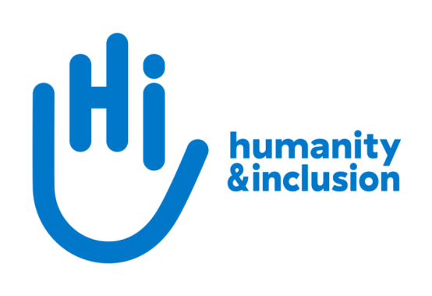

**Fundraising Officer: Digital**

**Application pack**

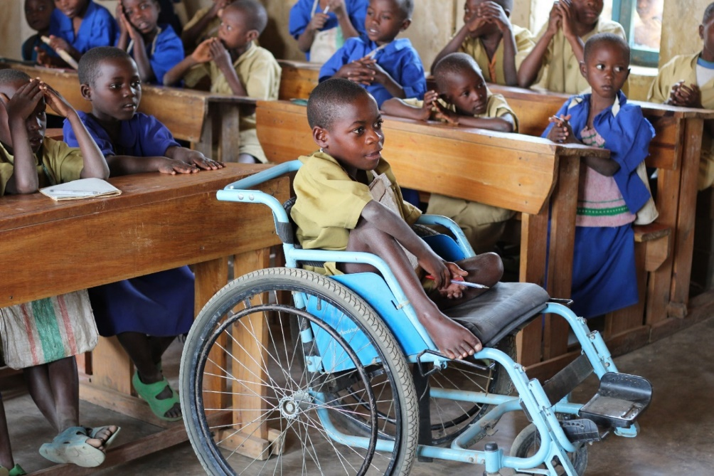

*A child taking an active part in a lesson, in an inclusive school, in Rwanda* ©J.McGeown/HI

**Do you want to improve the lives of people with disabilities and vulnerable people?**

Humanity & Inclusion (HI) is an award-winning international humanitarian and development organisation. Our UK team is looking for an enthusiastic and committed individual to join us as Digital Fundraising Officer. This is an exciting and varied role within our Individual Giving and Communications team, managing the development of our digital fundraising activities.

Individual giving is a key area of growth for HI and you will play a critical role in developing and protecting this future income, ensuring our vital work continues.

If you are motivated and target-driven, have a keen eye for detail and a proactive, hands-on approach to managing multiple priorities, we’d love you to join our small, friendly team.

**About Humanity & Inclusion (HI)**

Working alongside people with disabilities and vulnerable populations, we take action and raise awareness in order to respond to their essential needs, improve their living conditions and promote respects for their dignity and fundamental rights.

HI was co-winner of the 1997 Nobel Peace Prize for our campaign for the Mine Ban Treaty. We were also awarded the 2011 Hilton Humanitarian prize in recognition of our contribution to alleviating human suffering and supporting the most vulnerable people.



*Grace, 5, was born with a congenital disability. She lives in Kakuma refugee camp. Having received a prosthesis from HI, she goes to school and can play like any other child. She wants to be a teacher when she grows up. Here she is with Stella, her HI physiotherapist.*

©Patrick Meindhardt/HI

**Outraged by the injustice faced by people with disabilities and vulnerable populations, we aspire to a world of solidarity and inclusion, enriched by our differences, and where everyone can live in dignity.**

Respect for the rights of people with disabilities has been at the heart of HI’s approach sinceit was founded in 1982. Over forty years on, our organisation is still working and fighting around the world to improve the living conditions of people with disabilities and other vulnerable people and to ensure that their fundamental rights are respected.

**About Humanity & Inclusion UK (HI UK)**

HI UK is a member of the Humanity & Inclusion Network, which is comprised of a Federation and eight national associations. As part of the Network, HI UK works towards a common strategy while maintaining a distinct identity as a British organisation. The Federation is responsible for implementing the Network’s social missions in around fifty countries. It operates under the names “Humanity & Inclusion” or “Handicap International”, depending on the country.

HI has an ambitious delivery plan in the UK, as part of our 2016-25 strategy, [*For More Solidarity and Inclusion in the World*](https://hi.org/en/our-strategy).

# A picture containing screenshot, graphics, font, purple Description automatically generatedEqual opportunities policy

HI UK is committed to diversity and inclusion. We recognise that discrimination shapes the opportunities that many people have in society and that people have different needs in order to realise their full potential. Addressing this requires organisations to be proactive in creating environments that encourage the inclusion and development of all. Though we still have a long way to go, inclusion is central to our identity at HI UK and we are strongly committed to the continuous work that it requires.

We are particularly interested in hearing from candidates with disabilities and/or from minority ethnic backgrounds to help make us more representative. If you have a disability and meet the minimum requirements for the role, we will guarantee you an interview.

# Employee benefits

* All full-time employees are entitled to 28 days’ holiday per year in addition to UK public holidays.

* Training and development opportunities are open to all staff and will be provided in order to support them to fulfil their roles.
* We value all our employees and strive to support them in their professional lives. This includes offering flexible-working opportunities, including home-working and flexible hours.

* We offer a competitive workplace pension scheme, matching contributions up to 6% of gross salary.
* We are positive about employing persons with disabilities and are proud to be accredited as a Disability Confident Employer.
* We offer a Worklife Support Employee Assistance Programme, which provides confidential information, support and counselling.
* We strive to create a diverse and inclusive working environment and we are constantly looking at ways to improve our policies, processes and culture.
* Our office is conveniently located in London SE1 with great transport links to Waterloo, Blackfriars, London Bridge, and the London Underground.

**JOB DESCRIPTION**

**1.** **JOB TITLE** Fundraising Officer: Digital

**2.** **ORGANISATION** Humanity & Inclusion UK (HI UK)

**3.** **SALARY AND HOURS** £36,400 per annum / 37.5 hours a week

**4.** **REPORTING TO** Individual Giving & Communications (IGC) Team Manager; Fundraising Manager

**5.** **DURATION** Full-time permanent contract

**6.** **LOCATION** Hybrid with minimum 6 days per month in our office in London (SE1).

The applicant must have the right to work in the UK.

**7. BACKGROUND INFORMATION AND PURPOSE OF THE POST**

As part of our ambitious plans in the UK, we aim to achieve a step-change in private fundraising, taking a donor-centred approach, developing our digital fundraising and running multi-channel campaigns.

You will support the IGC Team Manager and Fundraising Manager to deliver HI UK’s individual giving strategy by developing and running our digital fundraising activities.

You will:

* Focus on increasing income from digital fundraising activities year on year.
* Lead the development of HI UK’s digital fundraising, focusing on email marketing and paid advertising.
* Maximise supporter engagement, conversion, retention and giving levels online.
* Produce engaging content to be used across digital channels.
* Monitor, analyse and report on key performance indicators to evaluate digital campaigns.
* Ensure our donors and supporters are at the heart of everything we do and that we provide them with a first-class experience.

**8.** **MAIN DUTIES AND RESPONSIBILITIES**

**Digital fundraising**

* Develop and implement multichannel digital fundraising campaigns, working with the Fundraising Manager.
* Maximise income and reach of HI UK’s emergency appeals by launching digital campaigns at short notice to enhance our online presence during the emergency.
* Design and produce creative content including video and images for use across digital fundraising and supporter engagement activities.
* Produce high-quality, timely and inspiring emails for HI UK’s donors and supporters, to increase income and engagement.
* Work with our digital agency to optimise Search Engine Advertising (paid and grant).
* Test and develop new paid media activities to support fundraising campaigns.
* Develop in-house and external Social Media Advertising campaigns to support fundraising objectives.
* Increase supporter engagement with HI UK’s organic social media content.
* Test and improve key supporter journeys across digital channels to increase income, conversion rate and engagement.
* Improve the website as a tool for fundraising and supporter engagement, focusing on the creation and development of landing pages, donation forms, and supporter actions.
* Increase volume and quality of traffic to HI UK’s website by developing and implementing SEO activities.

**Other duties**

* Work collaboratively with colleagues in the IGC team to implement and monitor digital activities in their areas of responsibility, including legacy fundraising, acquisition, loyalty, supporter care, and media outreach.
* Increase the level of integration of key digital platforms and databases and the automation of data transfers.
* Maintain a positive working relationship with the HI Federation fundraising and communication team, participating in the digital working group and feeding into digital transformation projects as required.
* Ensure HI brand guidelines and organisational values are respected in all digital marketing activities.
* Manage relationships with relevant suppliers and consultants.
* Represent the organisation at relevant external events and meetings.
* Keep up to date and adhere with any changes in legislation, regulatory procedures, innovation, best practice and industry standards in relation to digital fundraising.
* Any other activities commensurate with the level of the post, as may be required.

**Conduct and safeguarding**

Respect and dignity of all the people we support and come into contact with are at the heart of HI’s approach. All employees, volunteers (including trustees), partners, suppliers and consultants working with HI UK are expected to adhere to our [Code of Conduct and related policies**.**](https://hi.org/sn_uploads/document/ID_CodeOfConduct.pdf)

Our commitment to safeguarding means we seek to ensure that no harm comes to people as a result of contact with the organisation’s programmes, operations or people. This means ensuring the safety and protection of groups, including children and vulnerable adults, with whom the organisation is in contact, establishing safe and respectful workplaces that are free from harassment, abuse and discrimination, and maintaining HI’s reputation and high standards by preventing, addressing and learning from instances of wrongdoing.

This post is Safeguarding Level 1, which means no DBS check is required (unless the content of the post changes).

**9.**  **PERSON SPECIFICATION**

|  |
| --- |
| **ESSENTIAL** |
| Demonstrable experience of delivering multi-channel digital fundraising campaigns, or relevant digital marketing experience |
| Excellent copywriting skills with ability to adapt style to a wide variety of audiences |
| A proven track-record of meeting or exceeding targets across a variety of digital fundraising or marketing activities (e.g., email, PPC advertising, SEO and CRO) |
| Experience of managing website content management systems |
| Experience with online tracking and measurement platforms, such as Google Analytics, Tag Manager and Looker Studio |
| Excellent IT skills with good knowledge of Microsoft Office 365 and design software e.g. Canva and Adobe Creative Cloud |
| Ability to work in a complex, demanding environment whilst remaining focused on delivering results |
| Strong planning and organisational skills |
| Ability to gain results as part of a multi-disciplinary team and on own initiative |
| Excellent attention to detail |
| Excellent spoken and written communication skills |

|  |
| --- |
| **DESIRABLE** |
| Experience of video editing |
| Knowledge of HTML, CSS and Javascript |
| Knowledge of UX and persuasive design principles |
| Good financial management skills |
| Experience of working in an international multi-cultural charity/organisation |
| Lived experience of disability or from one of our countries of operation |
| French-language proficiency |

**APPLICATION PROCESS**

To apply for this role, please send your CV and a covering letter, along with the diversity monitoring form, by email or post.

By email: [recruitment.uk@hi.org](mailto:recruitment.uk@hi.org)

By post: Humanity & Inclusion UK (Recruitment), 9 Rushworth Street, London SE1 0RB

If you disclose a disability during your application process and you meet the minimum criteria for the role, we will contact you to discuss any reasonable adjustment you might need at the interview. However, if you have not disclosed, please be aware that any candidate invited for interview will be asked if any reasonable adjustments are needed.

If you wish to disclose a disability please do so in your covering letter.

## Closing date: Tuesday 12th September 2023, 11.59pm

Interviews are planned for the week of 18th September.

For further information, please contact Humanity & Inclusion UK on 0870 774 3737 or by email at [recruitment.uk@hi.org](mailto:recruitment.uk@hi.org).