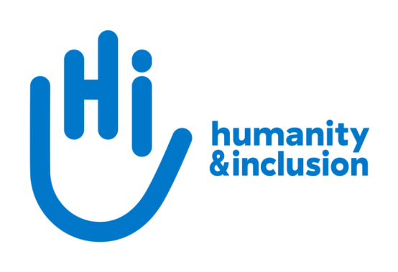

Commercial Contracts Manager

Application pack

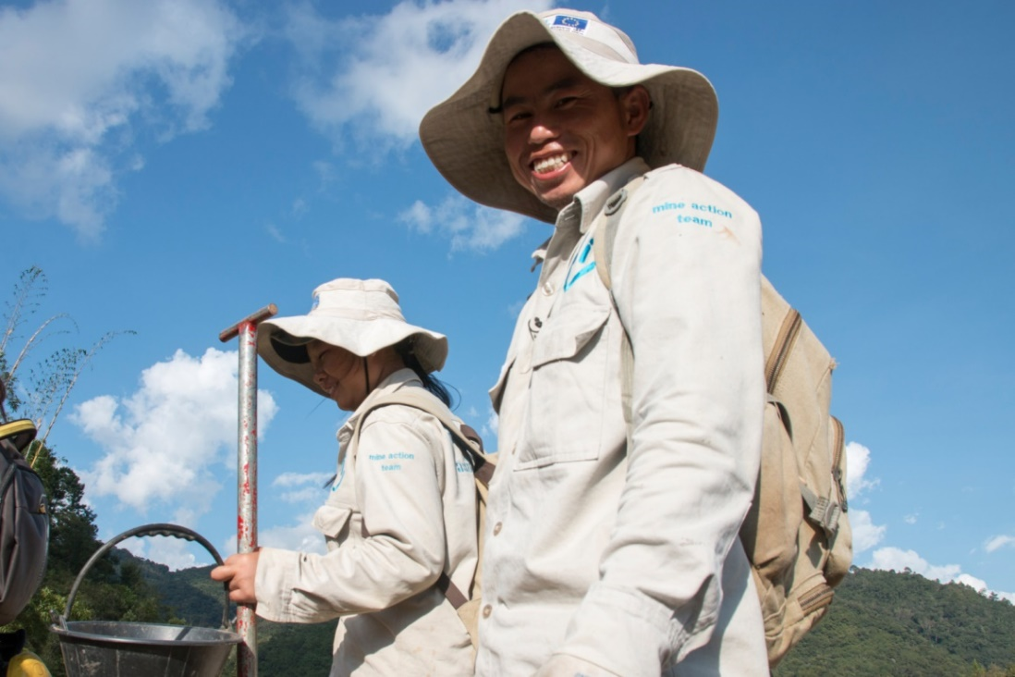

HI de-miners in Houaphan Province, Laos ©N.Lozano Juez/HI

Do you want to improve the lives of people with disabilities and vulnerable people?
Humanity & Inclusion (HI) is an award-winning international humanitarian and development organisation. Working alongside people with disabilities and vulnerable populations, we take action and raise awareness in order to respond to their essential needs, improve their living conditions and promote respects for their dignity and fundamental rights.

HI UK is looking for a Commercial Contracts Manager to coordinate our Foreign, Commonwealth and Development Office (FCDO) Framework Contracts (GDD and CSSF). This is a great opportunity to work across HI, coordinating country, technical and support teams, to enable us to secure and deliver funding as part of multiple consortia.

This role might suit someone with extensive experience of working with FCDO (on grants and / or contracts).

About Humanity & Inclusion (HI)

HI is co-winner of the 1997 Nobel Peace Prize for its work on the Mine Ban Treaty. We were also awarded the 2011 Hilton Humanitarian prize in recognition of our contribution to alleviating human suffering and supporting the most vulnerable people.
Grace, 5, was born with a congenital disability. She lives in Kakuma refugee camp. Having received a prosthesis from HI, she goes to school and can play like any other child. She wants to be a teacher when she grows up. Here she is with Stella, her HI physiotherapist.

©Patrick Meindhardt/HI

Outraged by the injustice faced by people with disabilities and vulnerable populations, we aspire to a world of solidarity and inclusion, enriched by our differences, and where everyone can live in dignity.

Respect for the rights of people with disabilities has been at the heart of HI’s approach since it was founded in 1982. Almost forty years on, our organisation is still working and fighting around the world to improve the living conditions of people with disabilities and other vulnerable people and to ensure that their fundamental rights are respected.

About Humanity & Inclusion UK (HI UK)

HI UK is a member of the Humanity & Inclusion Network, which is comprised of a Federation and eight national associations. As part of the Network, HI UK works towards a common strategy while maintaining a distinct identity as a British organisation. The Federation is responsible for implementing the Network’s social missions in around fifty countries. It operates under the names “Humanity & Inclusion” or “Handicap International”, depending on the country.

HI has an ambitious delivery plan in the UK, as part of our 2016-25 strategy, For More Solidarity and Inclusion in the World.

Equal opportunities policy

HI UK is committed to diversity and inclusion. We recognise that discrimination shapes the opportunities that many people have in society and that people have different needs in order to realise their full potential. Addressing this requires organisations to be proactive in creating environments that encourage the inclusion and development of all. Though we still have a long way to go, inclusion is central to our identity at HI UK and we are strongly committed to the continuous work that it requires.

We are particularly interested in hearing from candidates with disabilities and/or from Black and minority ethnic backgrounds, to help make us more representative. If you have a disability and meet the minimum requirements for the role, we will guarantee you an interview.

Employee Benefits

- All employees are entitled to 28 days’ holiday per year in addition to UK public holidays (pro rata for part-time employees). Colleagues may also take an additional day off for their birthday.

- Training and development opportunities are open to all staff and will be provided in order to support them to fulfil their roles.

- We value all our employees and strive to support them in their professional lives. This includes offering flexible-working opportunities, including home-working, flexible hours and two days’ volunteering leave each year.

- We offer a competitive workplace pension scheme, matching contributions up to 6% of gross salary.

- We are positive about employing persons with disabilities and are proud to be accredited as a Disability Confident Employer.

- We offer a Worklife Support Employee Assistance Programme, which provides confidential information, support and counselling.

- We strive to create a diverse and inclusive working environment and we are constantly looking at ways to improve our policies, processes and culture.

- Our office is conveniently located in SE1 with great transport links to Waterloo, Blackfriars, London Bridge and the London Underground. We run a hybrid-working approach, with colleagues expected to work from the office at least six days a month.

JOB DESCRIPTION

1. JOB TITLE Commercial Contracts Manager (CCM)

2. ORGANISATION Humanity & Inclusion UK (HI UK)

3. SALARY £42,360 per annum

4. REPORTING TO Head of Institutional Relations

5. DURATION Fixed term, 24 months, Full time

6. LOCATION London (SE1) with some remote working
The applicant must have the right to work in the UK

7. BACKGROUND INFORMATION AND PURPOSE OF THE POST

HI UK has successfully pre-qualified for multiple CSSF and GDD framework contracts as both a supplier and a subcontractor in various consortia. As part of the Institutional Relations team in the UK, and the global Institutional Funding Division, the Commercial Contracts Manager will be responsible for working with consortium Primes (a mixture of INGOs and for-profit organisations) and HI teams on all aspects of contracting, from consortium building, through call-down and implementation to closure.

Globally, HI has also pre-qualified for commercial contracting opportunities with other funders, and intends to pursue more: you will work with colleagues in other countries to share learning, develop and strengthen our internal systems and processes, and build our overall capacity for securing and delivering this type of funding.

8. MAIN DUTIES AND RESPONSIBILITIES

External coordination
- Lead communications with consortium partners, bringing in colleagues from relevant teams when appropriate
- Support contract negotiations and the provision of required documentation; facilitate the approvals and signature processes within HI
- With team members, liaise with FCDO as needed
- Negotiate and manage changes to contracts during implementation, including cost / no-cost extensions, as needed
- Manage payment requests and tracking
Internal coordination
- Be the link between Primes and HI teams, relaying questions and concerns, troubleshooting and bringing in support as needed
- Facilitate Go / No Go decision-making on each call-down opportunity
- Ensure that all internal stakeholders are clear on roles and responsibilities, deliverables, compliance and reporting requirements
- Ensure quality and compliance of proposals, reports and other documents as needed, providing guidance and practical support (including writing and editing)
- Create, test and strengthen tools and processes, as needed
- Liaise closely with the Commercial Contracts Financial Manager (to be based in France), who will be responsible for finance and budgeting for Framework Contracts

Organisation strengthening
- Continually develop and maintain expertise on FCDO priorities, expectations and compliance requirements; proactively analyse, interpret and share this knowledge internally with relevant colleagues across the Federation
- With the Institutional Relations team, build the ability of our country programmes to build consortia and to comply with FCDO requirements, including through training
- Contribute to building HI’s capacity to bid for and manage commercial contracts, including frameworks
- Keep abreast of developments within the sector by liaising with counterparts in other NGOs and relevant networks
- Keep up to date with any relevant changes in legislation, regulatory procedures, innovation, best practice and industry standards
- Any other activities commensurate with the level of the post, as may be required

Conduct and safeguarding

Respect and dignity of all the people we support and come into contact with are at the heart of HI’s approach. All employees, volunteers (including trustees), partners, suppliers and consultants working with HI UK are expected to adhere to our Code of Conduct and related policies.

Our commitment to safeguarding means we seek to ensure that no harm comes to people as a result of contact with the organisation’s programmes, operations or people. This means ensuring the safety and protection of groups, including children and vulnerable adults, with whom the organisation is in contact, establishing safe and respectful workplaces that are free from harassment, abuse and discrimination, and maintaining HI’s reputation and high standards by preventing, addressing and learning from instances of wrongdoing.

This post is Safeguarding Level 1, which means no DBS check is required (unless the content of the post changes).

9. PERSON SPECIFICATION
ESSENTIAL
Relevant commercial contract management experience within INGOs or development agencies.
Proven track record of securing, implementing and monitoring contracts with institutional funders, as part of sole / prime / sub-contracting organisation.
Experience of consortium working
Proven experience of developing and implementing policies, procedures and supporting tools to a wide range of audiences.
Proven ability to design, deliver and edit high-quality written documents
Evidence of strong interpersonal skills to guide programme teams and to work cross-departmentally with technical and programme colleagues
Excellent negotiation and communication skills for a range of audiences, including funders and external INGO networks
Ability to carry out sound strategic analysis, taking into account internal and external considerations
Strong planning skills and an ability to work under pressure, with an ability to prioritise, and meet standards and deadlines
Collaborative team player
Positive about creating and maintaining an inclusive and protective environment for everyone that comes in contact with the organisation
Fluent in English
DESIRABLE
Willingness and ability to travel within Europe and to field locations for periods of up to two weeks
Lived experience of disability or from one of our countries of operation
French language proficiency
Track record of working with, securing or managing funding from DFID/FCDO/FCO
Experience or studies in international development, social sciences, public health or any other relevant domain
Previous experience providing face to face and/or distance training

We genuinely value diversity, and are looking to build a team of people with a wide of range of personal and professional experience. If you don’t meet all of the criteria listed above, but feel you would be a good candidate for this role, please apply. If you would like an informal conversation about this, please do send us an email or call us – we would love to hear from you.

APPLICATION PROCESS

To apply, please send your CV and a covering letter form by email or post. Please also complete our Diversity monitoring form online.

By email: recruitment.uk@hi.org
By post: Humanity & Inclusion UK (Recruitment), 9 Rushworth Street, London SE1 0RB

If you disclose a disability during your application process and you meet the minimum criteria for the role, we will contact you to discuss any reasonable adjustment you might need at the interview. However, if you have not disclosed, please be aware that any candidate invited for interview will be asked if any reasonable adjustments are needed.
If you wish to disclose a disability please do so in your covering letter.

Closing date: 17th March 2024
Remote interviews, which will include a short written exercise, are planned for the week of 25th March.

For further information, please contact Humanity & Inclusion UK on 0870 774 3737 or by email at recruitment.uk@hi.org.

