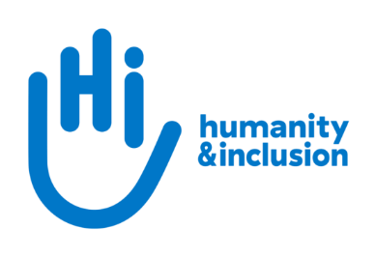

**Chair of Board of Trustees**

**Application pack**

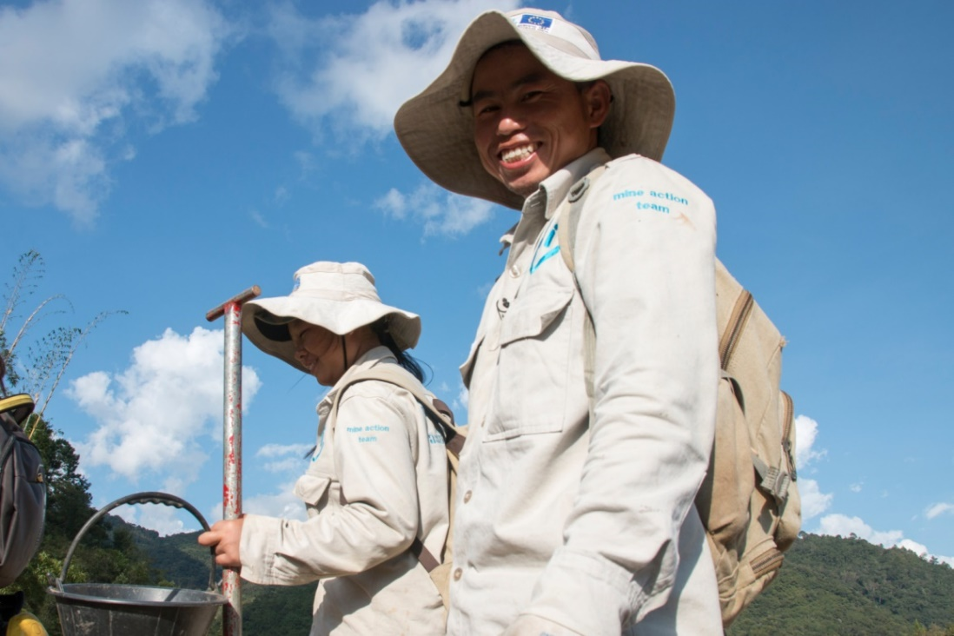

*HI deminers in Houaphan Province, Laos*  © N. Lozano Juez/HI

**Do you want to improve the lives of people with disabilities and vulnerable people?**

Humanity & Inclusion (HI) is an award-winning international humanitarian and development organisation. Working alongside people with disabilities and vulnerable populations, we take action and raise awareness in order to respond to their essential needs, improve their living conditions and promote respect for their dignity and fundamental rights.

HI UK is looking for an experienced, enthusiastic and committed individual to join us as the Chair of Board of Trustees. If you have leadership and board experience, great diplomacy and interpersonal skills, and a commitment to disability inclusion and international development, we’d love to hear from you.

**About Humanity & Inclusion (HI)**

HI is co-winner of the 1997 Nobel Peace Prize for its work on the Mine Ban Treaty. We were also awarded the 2011 Hilton Humanitarian prize in recognition of our contribution to alleviating human suffering and supporting the most vulnerable people.

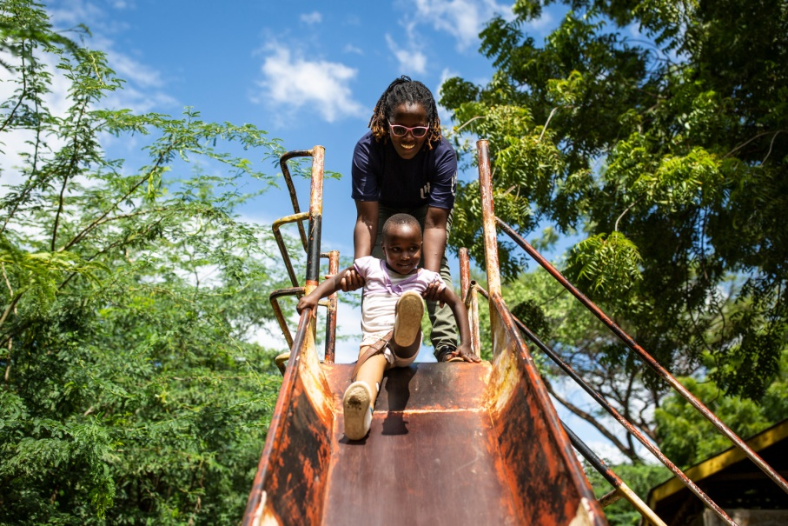

*Grace, 5, was born with a congenital disability. She lives in Kakuma refugee camp. Having received a prosthesis from HI, she goes to school and can play like any other child. She wants to be a teacher when she grows up. Here she is with Stella, her HI physiotherapist.*

© Patrick Meindhardt/HI

**Outraged by the injustice faced by people with disabilities and vulnerable populations, we aspire to a world of solidarity and inclusion, enriched by our differences, and where everyone can live in dignity.**

Respect for the rights of people with disabilities has been at the heart of HI’s approach sinceit was founded in 1982. Over forty years on, our organisation is still working and fighting around the world to improve the living conditions of people with disabilities and other vulnerable people and to ensure that their fundamental rights are respected.



**About Humanity & Inclusion UK (HI UK)**

HI UK is a member of the Humanity & Inclusion Network, which is comprised of a Federation and eight national associations. As part of the Network, HI UK works towards a common strategy while maintaining a distinct identity as a British organisation. The Federation is responsible for implementing the Network’s social missions in almost sixty countries. It operates under the names “Humanity & Inclusion” or “Handicap International”, depending on the country.

HI has an ambitious delivery plan in the UK, as part of our 2016-25 strategy, [*For More Solidarity and Inclusion in the World*](https://hi.org/en/our-strategy).

# Equal opportunities policy

HI UK is committed to diversity and inclusion. We recognise that discrimination shapes the opportunities that many people have in society and that people have different needs in order to realise their full potential. Addressing this requires organisations to be proactive in creating environments that encourage the inclusion and development of all. Though we still have a long way to go, inclusion is central to our identity at HI UK, and we are strongly committed to the continuous work that it requires.

We are particularly interested in hearing from candidates with disabilities and/or from Black and minority ethnic backgrounds, to help make us more representative. If you have a disability and meet the minimum requirements for the role, we will guarantee you an interview.

# Role description

1. **Position**: Chair of Board of Trustees
2. **Remuneration:** This is a voluntary role and unremunerated; however, reasonable travel expenses will be covered.
3. **Term of office:** Up to two terms of three years each.
4. **Time commitment:** Approximately two days per month with some travel to London (SE1) and Lyon.
5. **Background information and purpose of the post:**

HI UK is a UK charity and part of the HI Federal Network. The successful candidate will both lead and be an active member of the HI UK board, alongside working with the HI Federal General Assembly.

Being a part of a charity making a real difference on a global scale, this is an incredibly rewarding role. The successful candidate will provide leadership for HI in the UK, while engaging with and influencing the wider global work of the HI Federal Network.

As a trustee of a UK charity, you will:

* Ensure HI UK is carrying out its purposes for the public benefit
* Comply with the HI UK Articles of Association and the law
* Act in the best interests of HI UK
* Ensure the responsible management of HI UK’s resources
* Act with reasonable care and skill
* Ensure HI UK is accountable

As part of the HI Federal Network, you will:

* Commit to respect and defend HI’s purpose, mission, range of activity, founding values and principles that led to its creation
* Adhere to the HI Federal Network principles of solidarity, common good, delegation, mutual accountability and representation
* Contribute and adhere to the strategic direction and organisational and operational structure defined collectively for the future of the Network

1. **Main duties and responsibilities:**

As Chair of HI UK Board of Trustees, the successful candidate’s responsibilities will cover the activities of HI UK, alongside elements with the HI Federal Network. We have identified a few key areas in addition to the usual commitments of a charity trustee ([read more here](https://www.gov.uk/guidance/charity-trustee-whats-involved)).

UK:

* Chair board meetings and participate in one of the Board's sub-committees (currently focused on HR and Finance & Risk)
* Share line-management responsibility for the UK Chief Executive (together with the Federal Managing Director)
* Ensure the trustees comply with their duties and the charity is well-governed
* Be responsible for ensuring appropriate board composition and trustee recruitment

Federal:

* Member of the Federal Board of Trustees on a rotating basis with other National Association Chairs
* Member of the Federal College of Presidents, with regular meetings
* Ensure open and regular dialogue with the Federal President

***Conduct and safeguarding***

Respect and dignity of all the people we support and come into contact with are at the heart of HI’s approach. Our commitment to safeguarding means we seek to ensure that no harm comes to people as a result of contact with the organisation’s programmes, operations or people. All employees, volunteers (including trustees), partners, suppliers and consultants working with HI UK are expected to adhere to our [Code of Conduct and related policies**.**](https://hi.org/sn_uploads/document/ID_CodeOfConduct.pdf)

HI is a member of the inter-agency Misconduct Disclosure Scheme (MDS). In line with the principles of this scheme, when we contact your referees we will request that they provide information in relation to any findings of sexual exploitation, sexual abuse and/or sexual harassment (‘Misconduct’) or any allegations of this kind that were under investigation at the point that you left their organisation.

This post is Safeguarding Level 1, which means no DBS check is required (unless the content of the post changes).

1. **Person specification:**

*Experience and skills*

We are looking for candidates with:

* Experience working in or serving on the board of a federated organisation
* Diplomacy and interpersonal skills, including good listening, questioning and negotiating
* Ability to understand the international development, disability inclusion and charity sectors and to keep abreast of relevant issues, changes and debates
* Leadership experience gained at board or senior management level of a large or international organisation
* Ability to help raise awareness of HI UK, ideally including access to a strong network of influential people or organisations, media outlets, public figures etc
* Experience with different types of fundraising or access to a network of potential donors - across institutional donors, individual giving, corporate and/or other major donors
* Time to commit to the role

Additional desirable experience and skills include:

* Relevant lived experience – e.g. of disability or from one of the countries where we work
* International experience or knowledge of humanitarian response, disability inclusion and/or international development
* French language skills

*Personal characteristics*

We are looking for a chair with the following qualities and behaviours:

* Motivation and style:
  + Altruistic
  + Inclusive and empowering
  + Friendly and kind
  + Humble
  + Sense of humour
* Capacity to lead:
  + Committed to the organisation
  + Devotes enough time to the organisation
  + Clear about the role
  + Capable of seeing the ‘big picture’
  + Capable of clarifying issues
  + Capable of handling contentious issues
  + Capable of collaborating
* Personal attributes:
  + Emotionally intelligent
  + Confident
  + Reflective/listener
  + Organised
  + Focused
  + Open/innovative
* Ability to relate:
  + Flexible
  + At ease with people of all types
  + Non-judgemental
  + Calm
* Ability to advance the organisation externally:
  + Willing to use connections to advance the organisation
  + Ability to represent HI and comfort both with public speaking and facilitating discussion in intimate groups

We genuinely value diversity and are looking to build a team of people with a wide of range of personal and professional experience. If you don’t meet all of the criteria listed above but feel you would be a strong candidate for this role, please apply. If you would like an informal conversation about this, please do send us an email or call us – we would love to hear from you.

**HOW TO APPLY**

To apply, please send your CV and a covering letter to Mollie Gardner on [recruitment.uk@hi.org](mailto:recruitment.uk@hi.org). **Deadline: 11th September.**

Please also complete our [Diversity monitoring form](https://forms.gle/uJZDKjHdS8z2uCyYA) online.

If you disclose a disability during your application process and you meet the minimum criteria for the role, we will contact you to discuss any reasonable adjustment you might need at the interview. In all cases, candidates invited for interview will be asked if any reasonable adjustments are needed. If you wish to disclose a disability, please do so in your covering letter.

We plan to hold interviews in the week commencing either 16th or 23rd September.

We will seek two references for this role.

To find out more or to ask any questions please contact Mollie Gardner on [recruitment.uk@hi.org](mailto:recruitment.uk@hi.org).