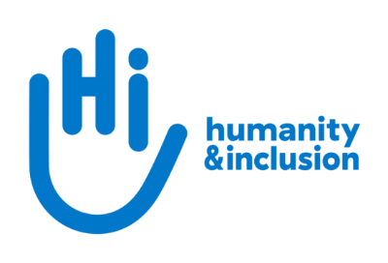

Application pack: Institutional Funding Volunteer

Do you want to improve the lives of people with disabilities and vulnerable people?

Humanity & Inclusion UK is looking for an Institutional Funding Volunteer to join our small, dynamic and friendly team in our London office. You will be supporting the work of our Institutional Relations team, and getting involved in tasks such as identifying new funding opportunities, managing our data and information, and developing internal and external communications content. Your work will be essential in helping our team work internally with technical and programmes colleagues across our countries of operation and externally with potential partners and donors to secure and manage institutional funding from the UK, Australian and Irish governments.

By volunteering with us, you will have the opportunity to gain first-hand experience of working for a charity and will contribute to our work supporting people with disabilities and other vulnerable groups worldwide, while learning new skills.

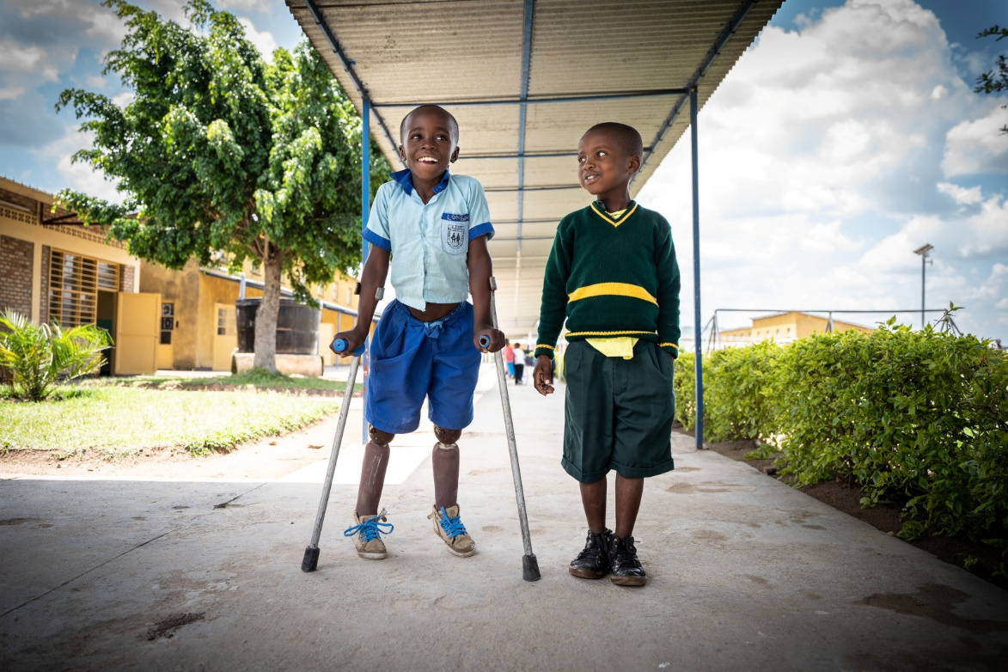
Photo: Longini (left) received prosthetic legs and support to go to school.
Rwanda © S. Wohlfahrt / HI

About Humanity & Inclusion

Humanity & Inclusion (HI) is an award-winning international charity working in situations of poverty and exclusion, conflict and disaster. We work tirelessly alongside disabled and vulnerable people to help meet their basic needs, improve their living conditions and promote respect for their dignity and fundamental rights.

Outraged by the injustice faced by people with disabilities and vulnerable populations, we aspire to a world of solidarity and inclusion, enriched by our differences, where everyone can live in dignity.

Since HI was founded in 1982, our work has benefitted tens of millions of people worldwide. In 2024, we ran 480 projects in 58 countries, directly supporting over 3.1 million people.

HI is a co-winner of the 1997 Nobel Peace Prize for our work towards banning and clearing anti-personnel landmines. We were also awarded the 2011 Hilton Humanitarian prize in recognition of our contribution to alleviating human suffering and supporting the most vulnerable people.

About Humanity & Inclusion UK (HI UK)

HI UK is a member of the HI Network, which is comprised of a Federation and eight national associations. As part of the Network, HI UK works towards a common strategy while maintaining its distinct identity as a UK charitable organisation. The HI Federation is responsible for implementing the Network’s social missions around the world. It operates under the names “Humanity & Inclusion” or “Handicap International”, depending on the country of operation.

Equal Opportunities Policy

HI UK is committed to diversity and inclusion. We recognise that discrimination shapes the opportunities that many people have in society and that people have different needs in order to realise their full potential.

Addressing this requires organisations to be proactive in creating environments that encourage the inclusion and development of all. Though we still have a long way to go, inclusion is central to our identity at HI UK and we are strongly committed to the continuous work that it requires.

We are particularly interested in hearing from candidates with disabilities and/or from Black and minority ethnic backgrounds, to help make us more representative. If you declare a disability and you meet the minimum requirements for the role, we will offer you an interview to demonstrate your skills. In the event that we receive a high level of applications for a role, we will invite those applicants who best meet the person specification.
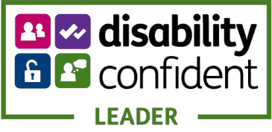

The role and the team

The main purpose of this role is to support the work of HI UK’s Institutional Relations team. The volunteer will work with all the members of our small team and have the opportunity to get involved in supporting a variety of tasks. The team’s work includes:
- Identifying new institutional funding opportunities from our donors relevant to HI’s teams.
- Supporting HI teams across our countries of operation to position with potential partners and develop proposals.
- Completing due diligence assessment requests from our potential partners/donors.
- Coordinating the internal review and signing of new funding agreements/contracts.
- Managing grants, including requesting payments, reviewing and submitting reports.
- Supporting HI UK’s annual audit and other compliance requirements
- Managing and keeping internal information management systems updated including our SharePoint filing system for document management and our Customer Relationship Management (CRM) database.
- Maintaining our institutional funding pages on HI’s intranet and developing internal guidance / updates / training for HI teams.
- Producing communications products for external audiences demonstrating our track record in institutional funding and project delivery.

Main duties and responsibilities

The specific duties will depend on the evolving priorities of the team which vary from day-to-day based on the live funding opportunities, deadlines, support requests etc. They are likely to include:
- Looking for new institutional funding opportunities
- Creating communications content to help HI position with potential partners/donors
- Supporting grant management e.g. uploading reports
- Updating our database and ensuring good document management
- Collating documents for the annual audit
- Developing new content for our intranet and website

You will also have the opportunity to gain experience of the humanitarian and international development sector, for example through:
- Completing HI’s e-learning induction package (including a module on disability inclusion)
- Reading/reviewing proposals and reports
- Researching donor trends and strategies
- Attending cross-organisation meetings on a range of topics including updates from our programmes and technical teams

Person specification

We genuinely value diversity and are looking to build a team of people with a wide of range of personal and professional experience. If you don’t meet all of the criteria listed below but feel you would be a good candidate for this role, please apply. If you would like an informal conversation about this, please do send us an email or call us – we would love to hear from you.

Essential criteria

- Excellent attention to detail.
- Competent in the use of Microsoft Office (especially Word, Excel, Outlook, Teams).
- Strong planning and organisational skills.
- Excellent written and verbal communication skills in English.
- Initiative and the ability to work independently.
- A positive attitude to working as part of a small team.
- An interest in international charities.

Desirable criteria

- Knowledge about institutional funding and the wider international development and humanitarian sectors.
- Experience of entry level design tools (e.g. Canva), updating websites/intranets, CRM databases and SharePoint.
- Lived experience of disability.

Hours

Hours will be agreed with the volunteer, in accordance with availability. Ideally, you would be available for at least 14 hours per week and able to commit to an initial 4 month period with possibility to extend but this is flexible.

This is a voluntary position but we make contributions to lunch (up to £10/day) and travel costs (up to £15.60/day) on presentation of receipts.

Location

Humanity & Inclusion UK’s office is situated in London SE1. It has an open plan setting.

This volunteer role can be done in the office (when other staff are in) or through a combination of coming into the office and working from home/elsewhere. The contributions to lunch and travel expenses will be provided only for days the volunteer comes into the office.

Conduct and safeguarding

Respect and dignity of all the people we support and come into contact with are at the heart of HI’s approach. All employees, volunteers (including trustees), partners, suppliers and consultants working with HI UK are expected to adhere to our Code of Conduct and related policies.

Our commitment to safeguarding means we seek to ensure that no harm comes to people as a result of contact with the organisation’s programmes, operations or people. This means ensuring the safety and protection of groups, including children and vulnerable adults, with whom the organisation is in contact, establishing safe and respectful workplaces that are free from harassment, abuse and discrimination, and maintaining HI’s reputation and high standards by preventing, addressing and learning from instances of wrongdoing.

This post is Safeguarding Level 1, which means no DBS check is required (unless the content of the post changes).

Application Process

Fill in the volunteering application form and send it along with your CV by email or post to recruitment.uk@hi.org or Humanity & Inclusion UK (Volunteering), Romero House, 55 Westminster Bridge Road, London SE1 7JB.

The deadline for applications is 23:59 on Sunday 22 February.

For further information, please contact us on 0870 774 3737 or by email at recruitment.uk@hi.org.

If you disclose a disability during your application process and you meet the minimum criteria for the role, we will contact you to discuss any reasonable adjustments you might need at the interview. However, if you have not disclosed, please be aware that any candidate invited for interview will be asked if any reasonable adjustments are needed. If you wish to disclose a disability, please do so in your covering letter.

For further information, please contact Humanity & Inclusion UK on 0870 774 3737 or by email at recruitment.uk@hi.org.

